A Project Report

on

**A Python Application For**

**Library Management**

Submitted to



**CV RAMAN UNIVERSITY BILASPUR**

***in partial fulfillment of requirement for the award of degree of***

**Diploma in Computer Application**

## By

**“--------------------------”**

Under the Guidance of

**---------------------**

**Registered Study centre**

**--------------------------------------------------------------------**

## DEPARTMENT OF COMPUTER APPLICATION

## D R C V R A M A N U N I V E R S I T Y B H I L A S P U R **( C.G. )**

**SESSION** **2023-24**

DECLARATION

We the undersigned solemnly declare that the report of the project work entitled “**A Python Application for Library management**” is based on my own work carried out during the course of our study.

We assert that the statements made and the conclusions drawn are the outcome of the project work. I further declare that to the best of our knowledge and belief that the report does not contain any part of work which has been submitted for the award of any other degree/diploma/certificate in this university or any other university.

Name ------------------------

Roll Number: -------------

**CERTIFICATE**

This is to certify that the report of the project submitted is an outcome of the project work entitled **“A Python Application for Library management”** carried out by

Name --------------------- Roll Number: ----------------------

under my guidance and supervision for the award of Degree in **Diploma** in **Computer Application** in Computer Applicationof DR CV RAMAN University, Bilaspur (C.G.), India.

To the best of my knowledge the report,

Embodies the work of the candidate him/herself has duly been completed, Fulfills the requirement of the ordinance relating to the BE degree of the University and is up to the desired standard for the purpose of which is submitted.

## ----------------------

Trainer / Institude head

## Department of Computer Application

## DR C V RAMAN UNIVERSITY BILASPUR ( C. G. )

**CERTIFICATE BY THE EXAMINERS**

This is to certified that the project work entitled-

## “**A Python Application for Library management**”

|  |  |  |
| --- | --- | --- |
| Submitted by |  | |
| --------------------------- | Roll No | -------------------- |
|  |  | : |

Has been examined by the undersigned as a part of the examination for the award of Diploma in Computer Application degree of DR CV RAMAN UNIVERSITY , BILASPUR

Internal Examiner External Examiner

-

-

-

## ACKNOWLEDGEMENT

I have great pleasure in the submission of this project report entitled **A Python Application for Library management** for Name in patial fulfillment the degree of **DCA in** **Computer Application**. While Submitting this Project report, I take this opportunity to thank those directly or indirectly related to project work

I would like to thank my **Mr ----------------- Sir** of the guide in institute who has provided the opportunity and organizing project for me. Without his active cooperation and guidance, it would have become very difficult to complete task in time.

I would like to express sincere thanks and gratitude to ______________ **of the University, Head of Department, (Computer Science & Application)**.

While Submission of the project, I also like to thanks to **Prof. _______________,** and the staff of Name of the University for their continuous help and guidance throughout the course of project

Acknowledgment is due to our parents, family members, friends and all those persons who have helped us directly or indirectly in the successful completion of the project work

---------------------------

## Table of Content

|  |  |  |  |
| --- | --- | --- | --- |
|  | **Content** | | **Page No** |
| **Abstract** | |  |
| **List of figures** | |  |
|  | |  |
| **Chapter 1** | **Introduction** | |  |
|  | Problem Statement | |  |
|  | Objectives | |  |
|  | Background | |  |
| **Chapter 2** | **Literature Review** | |  |
|  | Existing Library Management System | |  |
|  | Benefits of JSON and tkinter | |  |
|  | Advantage of tkinter for GUI | |  |
| **Chapter 3** | **Theoretical Framework** | |  |
|  | LMS as a Service/Product | |  |
|  | LMS Versatility | |  |
| **Chapter 4** | **Problem Identification** | |  |
|  | Inefficiency | |  |
|  | Inaccuracy | |  |
|  | Limited Data Access | |  |
|  | Additional challenges | |  |
|  | Scalability | |  |
|  | Security | |  |
|  | User Experience | |  |
| **Chapter 5** | **Design Phase** | |  |
| **Chapter 6** | **Methodology** | |  |
| **Chapter 7** | | Result and discussion | |
| **Conclusion** | |  | |
| **Bibliography** | |  | |

## 

**Abstract**

We are developing a website using Iterative model which is provide in **A Python Application for Library management**. We are trying to develop a platform who can be able to suggest approx all of the functionality of Library management.

The Library Management System (LMS) is a Python-based application designed to facilitate the management of library operations. It features a graphical user interface (GUI) developed using Tkinter and utilizes JSON files for data storage, making it lightweight and easily deployable without requiring external database software. The LMS addresses common challenges in library management by automating tasks such as book cataloging, borrower tracking, and due management. This system aims to replace traditional paper-based methods, enhancing efficiency, accuracy, and user experience.



## List of Figures

### List of Figures

1. Welcome Page Screenshot
2. Admin Login Page Screenshot
3. Book List Page Screenshot
4. Borrowers Page Screenshot
5. Due Page Screenshot
6. Authors page Screenshot
7. User Section page Screenshot

# Chapter 1 Introduction

## Introduction

Libraries are essential institutions for education and community development, providing access to a vast array of knowledge resources. However, managing these resources efficiently has always been a challenging task. Traditional library management systems rely heavily on manual processes, which are time-consuming and prone to errors. With the advent of digital technology, there is an opportunity to modernize library management systems, making them more efficient, accurate, and user-friendly.

The Library Management System (LMS) is designed to address these challenges by offering a digital solution that automates routine library tasks. The system provides a graphical user interface (GUI) for easy interaction, and it uses JSON files for data storage to ensure persistence without the need for complex database setups. The LMS enables librarians to manage book inventories, track borrowings, handle due dates, and maintain accurate records of borrowers, thereby improving the overall efficiency of library operations.

### Problem Statement

Libraries face several challenges in managing their operations, especially when using traditional paper-based systems. These challenges include:

* **Inefficiency**: Manual processes for tracking borrowings, returns, and due dates are time-consuming and labor-intensive.
* **Errors**: Human errors in record-keeping can lead to inaccuracies, misplaced books, and incorrect due tracking.
* **Data Management**: Maintaining up-to-date records of books and borrowers is difficult with paper-based systems.
* **User Experience**: Traditional systems do not provide real-time access to information, making it difficult for users to check book availability or due dates.

The LMS aims to solve these problems by providing a digital platform that automates library operations, ensuring efficiency, accuracy, and improved user experience.

### Objectives

The primary objectives of the Library Management System are:

**Develop a User-Friendly GUI using Tkinter**

* **Intuitive Design:** Create a visually appealing and easy-to-navigate interface that requires minimal training for librarians and users.
* **Clear Labeling:** Ensure all buttons, fields, and menus are clearly labeled to prevent confusion.
* **Logical Layout:** Organize interface elements in a logical manner to facilitate efficient task completion.
* **Error Handling:** Implement informative error messages to guide users in correcting input mistakes.
* **Accessibility:** Consider design principles for users with disabilities to make the system inclusive.

### Implement Book Management Functions

* **Book Addition:** Allow librarians to input book details such as title, author, ISBN, publication date, and number of copies.
* **Book Search:** Enable users to search for books by title, author, or subject.
* **Book Borrowing:** Track book checkouts, including borrower information and due date.
* **Book Returning:** Process book returns, updating inventory and borrower records.
* **Inventory Management:** Maintain accurate records of book availability and location.
* **Book Editing:** Allow librarians to modify book information if necessary (e.g., updating cover image, changing publication details).

### Track Borrowers and Due Dates

* **Borrower Registration:** Create profiles for library members, including personal information and borrowing history.
* **Due Date Calculation:** Automatically calculate due dates based on borrowing policies.
* **Overdue Notifications:** Send reminders to borrowers approaching or exceeding due dates.
* **Fine Calculation:** Implement a system for calculating overdue fines based on library policies.
* **Borrowing Limits:** Enforce borrowing limits per member.
* **Hold Requests:** Allow users to place holds on books that are currently checked out.

### Data Persistence using JSON Files

* **Data Storage:** Save all library data (books, borrowers, loans) in JSON format for long-term storage.
* **Data Retrieval:** Load data from JSON files upon application startup.
* **Data Backup:** Consider implementing regular backups of JSON files to prevent data loss.
* **Data Security:** Implement measures to protect sensitive borrower information (e.g., encryption).

**Additional Considerations:**

* **User Roles:** Define different user roles (librarian, student, faculty) with varying privileges.
* **Reports:** Generate reports on book circulation, overdue items, and library statistics.
* **Performance Optimization:** Ensure the system performs efficiently, even with a large number of books and users.
* **Scalability:** Design the system to accommodate future growth in book collection and user base.
* **Testing:** Thoroughly test the system to identify and fix errors before deployment.

## Background

### The Indispensable Role of Libraries

Libraries have served as cornerstones of communities for centuries, providing invaluable access to information, education, and culture. As repositories of knowledge, they have fostered learning, research, and personal growth for individuals of all ages. From historical texts and academic journals to novels and children's books, libraries offer a diverse collection of resources to cater to varied interests and needs.

### Challenges of Traditional Library Management

While libraries have been essential to society, managing them efficiently has presented significant challenges. Traditional methods of library management, often involving manual processes and paper-based systems, have been time-consuming and prone to errors. Tasks such as cataloging books, tracking borrower information, and managing due dates were labor-intensive and required meticulous attention to detail. Moreover, finding specific materials within a vast collection could be a daunting task for both librarians and patrons.

### The Need for Digital Transformation

The advent of digital technologies has offered a promising solution to the challenges faced by libraries. By leveraging digital tools and platforms, libraries can streamline operations, enhance user experience, and expand their services. A well-designed library management system can automate routine tasks, improve data accuracy, and provide real-time access to information. This, in turn, allows librarians to focus on more strategic tasks, such as collection development and user engagement.

**Key benefits of digital library management systems include:**

* **Improved efficiency:** Automation of tasks like cataloging, circulation, and inventory management.
* **Enhanced user experience:** Self-service options, online catalogs, and digital resources.
* **Better data management:** Accurate and up-to-date records of books, patrons, and circulation history.
* **Increased accessibility:** Remote access to library services and resources.
* **Cost reduction:** Reduced reliance on paper-based systems and manual processes.

By embracing digital transformation, libraries can better serve their communities and adapt to the evolving information landscape.

# Chapter 2

# Literature Review

### Existing Library Management Systems

Three major players in the ILS market: Koha, Evergreen, and SirsiDynix Symphony. These systems represent different approaches to library management, with varying levels of complexity and cost.

To strengthen your literature review, consider adding these elements:

* **Comparative Analysis:** Delve deeper into the specific features and functionalities offered by each system. Compare their strengths and weaknesses in areas such as cataloging, circulation, user interface, reporting, and mobile accessibility.
* **Target Audience:** Discuss the types of libraries that each system is best suited for. For example, Koha and Evergreen are often preferred by smaller to medium-sized libraries due to their open-source nature and lower costs. SirsiDynix Symphony, on the other hand, is typically used by larger institutions with complex needs.
* **Limitations and Challenges:** Highlight the common shortcomings of existing systems, such as steep learning curves, high implementation costs, and potential scalability issues. This will help justify the need for a simpler, more flexible solution like your proposed system.
* **User Feedback:** Incorporate findings from studies or surveys that explore user satisfaction with existing ILS. This can provide valuable insights into the pain points and expectations of library staff and patrons.

### Benefits of JSON and Tkinter

You've correctly identified JSON as a suitable data storage format for your library management system. To further strengthen your argument, consider these points:

* **JSON Advantages:** Elaborate on the specific benefits of JSON for data storage in this context, such as its readability, flexibility, and efficient parsing. Compare JSON to other potential data formats (e.g., XML, CSV) and explain why JSON is the preferred choice.
* **Tkinter Advantages:** Provide a more detailed explanation of why Tkinter

is a suitable choice for building the GUI. Highlight its simplicity, cross-platform compatibility, and integration with Python's standard library. Compare Tkinter to other GUI toolkits (e.g., PyQt, wxPython) and justify your decision to use Tkinter.

By expanding on these points, you can create a more comprehensive and persuasive literature review that supports the development of your library management system.

**Benefits of JSON for Data Storage**

### **Ease of Use**

* **Rapid Development:** JSON's simple syntax allows for quick development and modification of data structures.
* **Minimal Learning Curve:** Developers and librarians alike can easily grasp JSON's format, reducing training time.
* **Direct Integration with Python:** Python offers built-in libraries (like json) for seamlessly handling JSON data, streamlining development.

### Portability

* **Cross-Platform Compatibility:** JSON is language-independent, ensuring data can be shared across different systems and platforms.
* **Data Exchange:** Facilitates data exchange between the LMS and other applications or services.
* **Cloud Integration:** JSON is well-suited for cloud-based storage and retrieval of data.

### Human-Readability

* **Debugging and Troubleshooting:** Easily identify errors or inconsistencies in data by examining JSON files directly.
* **Data Validation:** Manually verify data accuracy before processing.
* **Collaboration:** Enhance teamwork by enabling multiple users to understand and work with the data.

### Additional Benefits

* **Efficiency:** JSON's compact structure leads to smaller file sizes and faster data transfer.
* **Scalability:** JSON can handle both small and large datasets effectively.
* **Flexibility:** Accommodates diverse data types (numbers, strings, arrays, objects) within a single structure.

****# Advantages of Tkinter for GUI Development****

### ****Built-In Library****

* **No Additional Dependencies:** Tkinter comes pre-installed with standard Python distributions, simplifying project setup and deployment.
* **Reduced Development Time:** Developers can start building the GUI immediately without the overhead of installing external libraries.

### Ease of Use

* **Intuitive Syntax:** Tkinter's syntax is relatively straightforward, making it accessible to programmers with varying levels of experience.
* **Rapid Prototyping:** Quickly create basic GUI elements to test concepts and iterate on design.
* **Extensive Documentation:** Python's rich documentation provides comprehensive support for Tkinter, aiding in learning and problem-solving.

### Cross-Platform Compatibility

* **Consistent User Experience:** Applications built with Tkinter can run

consistently across different operating systems (Windows, macOS,

Linux).

* **Wider User Base:** Reach a broader audience without requiring platform-specific development.

### Additional Advantages

* **Active Community:** A strong community of Tkinter users provides support, resources, and third-party extensions.
* **Performance:** While not the fastest GUI toolkit, Tkinter is generally sufficient for most library management system requirements.
* **Integration with Other Python Libraries:** Seamlessly combine Tkinter with other Python libraries for data processing, database interaction, and more.

# Chapter 3

***Theoretical Framework***

**# MVC Framework for the LMS**

### A Deeper Dive into MVC-

#### Model

* **Data Structures:** Define the specific data structures used to represent books, borrowers, and other relevant entities within the model.
* **Business Logic:** Outline the core business rules and calculations implemented in the model, such as calculating due dates, calculating fines, and managing book availability.
* **Data Persistence:** Explain how the model interacts with the JSON files to save and load data, including data validation and error handling.

#### View

* **User Interface Components:** Specify the Tkinter widgets used to create the various screens and dialogs of the LMS (e.g., labels, entry fields, buttons, lists, etc.).
* **Data Display:** Describe how the view retrieves data from the model and displays it to the user in a clear and informative manner.
* **User Input Handling:** Explain how the view captures user input (e.g., button clicks, text entries) and passes it to the controller.

#### Controller

* **Input Processing:** Detail how the controller interprets user input and translates it into actions.
* **Model Updates:** Describe how the controller updates the model based on user actions (e.g., adding a book, borrowing a book).
* **View Updates:** Explain how the controller communicates changes in the model to the view, triggering updates to the user interface.

### Benefits of MVC in the LMS Context

* **Maintainability:** Highlight how the separation of concerns makes the codebase easier to understand, modify, and extend.
* **Testability:** Discuss how the MVC architecture facilitates unit testing of individual components.
* **Reusability:** Explain how certain components (e.g., model classes) can be potentially reused in other parts of the application or even in different applications.
* **Scalability:** Discuss how the MVC architecture can accommodate future growth and expansion of the LMS.

## # LMS as a Service or Product

## Target Markets and Value Proposition

Three primary target markets for the LMS: educational institutions, public libraries, and individuals with large personal collections. To further the LMS as a service or product, we consider the following:

#### Educational Institutions

* **Value Proposition:** Increased efficiency in library management, improved student experience through easy access to resources, and data-driven decision making for library administrators.
* **Specific Features:** Consider features like integration with student information systems, course reserves, and interlibrary loan functionalities.
* **Pricing Model:** Explore options such as licensing fees, subscription models, or a combination of both.

#### Public Libraries

* **Value Proposition:** Enhanced patron satisfaction, optimized resource utilization, and cost savings through automation.
* **Specific Features:** Focus on features like self-checkout kiosks, online catalog integration, and community engagement tools.
* **Pricing Model:** Explore options like licensing fees, usage-based pricing, or revenue-sharing models.

#### Individuals

* **Value Proposition:** Easy organization and management of personal book collections, tracking loans, and generating personalized book recommendations.
* **Specific Features:** Consider features like barcode scanning, advanced search options, and export/import functionalities.
* **Pricing Model:** Explore options like one-time purchase, subscription-based access, or freemium models.

### Deployment Models

* **Cloud-Based LMS:** Offer the LMS as a Software-as-a-Service (SaaS) solution, hosted on a cloud platform. This provides accessibility, scalability, and reduced maintenance overhead for customers.
* **On-Premises LMS:** Provide the LMS as a software package for installation on the customer's servers. This offers greater control and customization options but requires additional IT resources.
* **Hybrid Model:** Combine the benefits of both cloud-based and on-premises deployments, offering flexibility to customers.

### Monetization Strategies

* **Licensing Fees:** Charge upfront or recurring fees for using the LMS.
* **Subscription Models:** Offer different subscription tiers with varying features and pricing.
* **Usage-Based Pricing:** Charge customers based on the number of users, transactions, or storage used.
* **Freemium Model:** Offer a basic version of the LMS for free and charge for premium features or additional storage.
* **Value-Added Services:** Generate revenue through additional services like data analytics, customization, or training.

## # LMS's Versatility

### Adapting the LMS for Diverse Applications

Several potential applications for the LMS beyond traditional library management.

#### Multimedia Resource Management

* **Asset Tracking:** Implement features to track ownership, location, and usage of digital media assets.
* **Metadata Management:** Allow for detailed metadata input (title, artist, genre, copyright information, etc.) for efficient search and retrieval.
* **Rights Management:** Incorporate tools to manage digital rights and permissions.
* **Digital Preservation:** Implement functionalities to ensure the long-term preservation of digital assets.

#### Inventory Tracking

* **Barcode Integration:** Enable efficient item tracking through barcode scanning.
* **Stock Management:** Implement features for managing stock levels, reorder points, and inventory valuation.
* **Supply Chain Integration:** Connect with supply chain management systems for streamlined operations.
* **Asset Depreciation:** Track the depreciation value of inventory items over time.

#### Document Management

* **Document Version Control:** Manage different versions of documents and track changes.
* **Access Control:** Implement user permissions and roles to protect sensitive documents.
* **Workflow Management:** Create automated workflows for document approval and routing.
* **Search and Retrieval:** Provide advanced search capabilities to locate documents quickly.

### Core Functionalities for Adaptation

To effectively adapt the LMS to these different domains, consider the following core functionalities:

* **Item Cataloging:** Create a flexible cataloging system to accommodate various types of resources (books, media, inventory items, documents).
* **Metadata Management:** Implement a robust metadata schema to capture relevant information about resources.
* **Circulation Management:** Adapt the circulation module to track the movement of resources (check-in, check-out, reservations).
* **User Management:** Manage user accounts, permissions, and roles.
* **Reporting:** Generate reports tailored to specific domains (e.g., inventory reports, usage statistics, financial reports).

# Chapter 4

# Problem

# Identification

## # Problem Identification

#### Inefficiency

* **Time-consuming manual tasks:** Detail the specific tasks that consume the most time, such as searching for books, processing checkouts and returns, and generating reports.
* **Resource allocation:** Explain how inefficient processes lead to sub optimal utilization of library staff and resources.

#### Inaccuracy

* **Data entry errors:** Describe the types of errors commonly made during manual data entry (e.g., incorrect book information, typos in borrower details).
* **Lost or misplaced items:** Explain the financial and operational impact of lost or misplaced items due to inaccurate records.
* **Overdue fines:** Discuss the challenges of accurately tracking due dates and calculating fines.

#### Limited Data Access

* **Information availability:** Explain the difficulties faced by librarians and patrons in accessing real-time information about book availability, user accounts, and library statistics.
* **Decision-making:** Describe how the lack of timely data hinders effective decision-making for library management.

#### Additional Challenges

* **Scalability:** Discuss the challenges of managing a growing book collection and user base with a paper-based system.
* **Security:** Highlight the risks of data loss or unauthorized access to sensitive information.
* **User Experience:** Describe the frustrations experienced by library patrons due to long wait times, inaccurate information, and limited self-service options.

### Quantifying the Problem

* How much time is spent on average by library staff on manual tasks?
* What is the estimated financial loss due to lost or damaged books?
* How many user complaints are received related to inaccurate information or long wait times?

# 

# Chapter 5 Design

# Phase

## # Design Phase

**Prioritization:** Once requirements are gathered, prioritize them based on importance and feasibility. This will help in focusing development efforts on the most critical features.

* **Use Cases:** Create detailed use cases to describe how users interact with the system. This will provide a clear understanding of system behavior.
* **User Personas:** Develop representative user profiles to guide design decisions and ensure the system meets user needs.
* **Data Flow Diagrams:** Visualize the flow of data through the system to identify potential bottlenecks or inefficiencies.

*Fig 1. Welcome page*

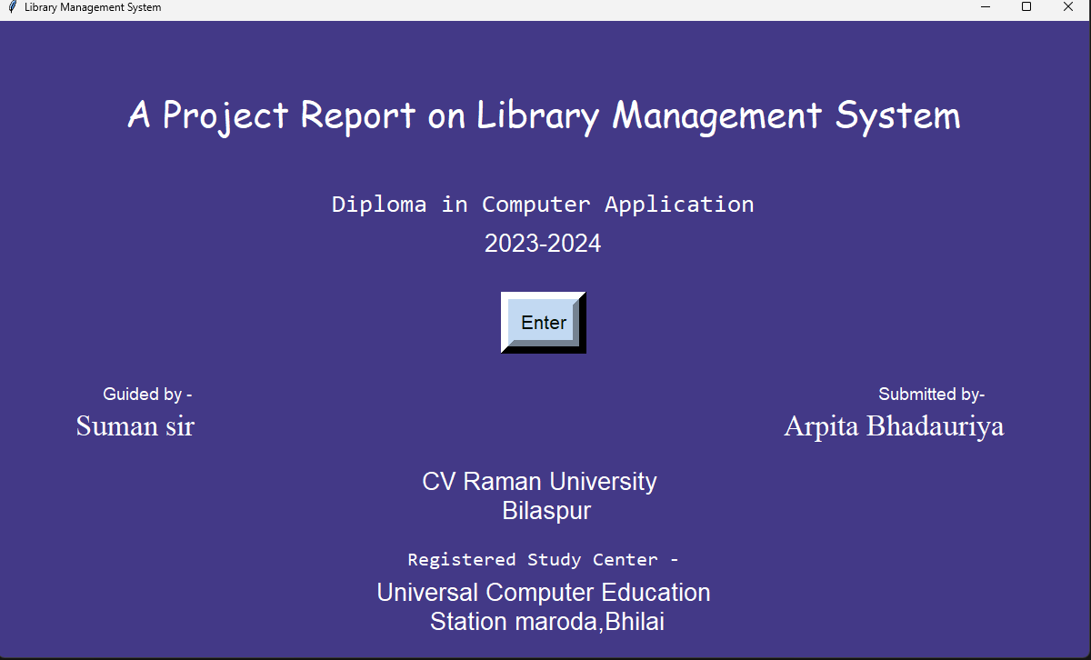

### System Architecture Design

Your description of the MVC architecture is accurate. To further elaborate:

* **Data Model:** Define the specific data structures used to represent books, borrowers, and other entities within the model.
* **Persistence Layer:** Specify how data is stored and retrieved from JSON files (e.g., file naming conventions, error handling).
* **Controller Logic:** Detail the specific rules and algorithms implemented in the controller (e.g., due date calculation, fine calculation).

*Fig 2 Admin login page*

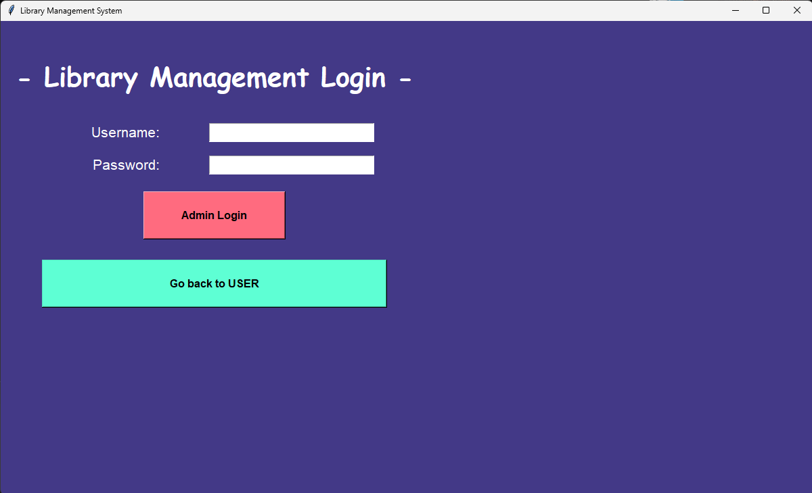

### GUI Design Using Tkinter

Your proposed GUI elements provide a good starting point. To enhance the design:

* **User Experience (UX) Design:** Consider factors like usability, accessibility, and visual appeal.
* **Wire framing:** Create low-fidelity wire-frames to visualize the layout and flow of the user interface.
* **Prototyping:** Develop interactive prototypes to test the design with potential users.
* **Error Handling:** Implement appropriate error messages and handling for different scenarios (e.g., invalid input, system errors).
* **Help and Support:** Provide in-app help or documentation to assist users.

*Fig 3 Book page*

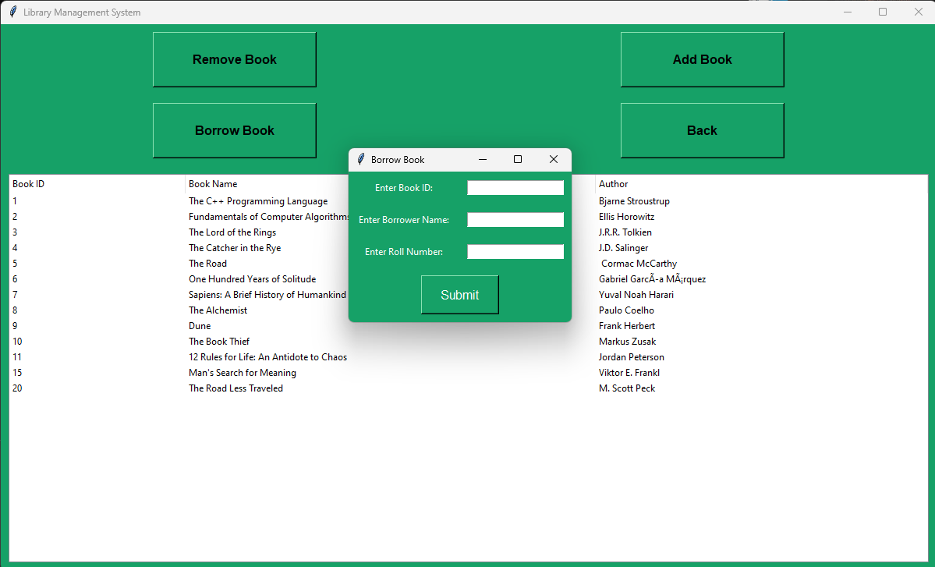

### Additional Design Considerations

* **Security:** Address security measures to protect user data (e.g., password hashing, access controls).
* **Performance:** Optimize the system for speed and responsiveness, especially when handling large datasets.
* **Scalability:** Design the system to accommodate future growth in terms of users, books, and data.
* **Maintainability:** Write clean, well-structured code with comments and documentation to facilitate future modifications.

*Fig 4 Borrowers Page*

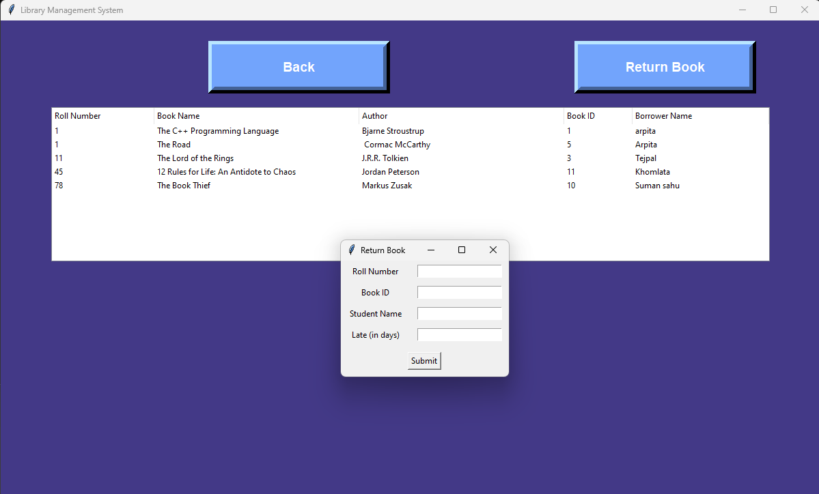

**#Data Storage Design Using JSON Files**

### **Enhancing the Data Storage Design**

To further optimize our data storage strategy, we consider the following:

#### Data Structure Considerations

* **Book Data:**
  + Include essential fields like ISBN, title, author, publication year, genre, number of copies, availability status, and location.
  + Consider additional fields for metadata like keywords, subject, and language.
  + For complex data structures, explore using nested JSON objects to represent book details efficiently.
* **Borrower Data:**
  + Store borrower ID, name, contact information, borrowing history, and overdue fines.
  + Implement a unique identifier for each borrower to establish relationships with borrowed books.
* **Due Date Data:**
  + Consider storing due date information within the book or borrower data, depending on your system's requirements.
  + If you opt for a separate due date file, ensure proper indexing for efficient retrieval.

#### File Naming Conventions

* Establish clear and consistent file naming conventions to easily identify and manage JSON files.
* Use meaningful names that reflect the file's content (e.g., books.json, borrowers.json).

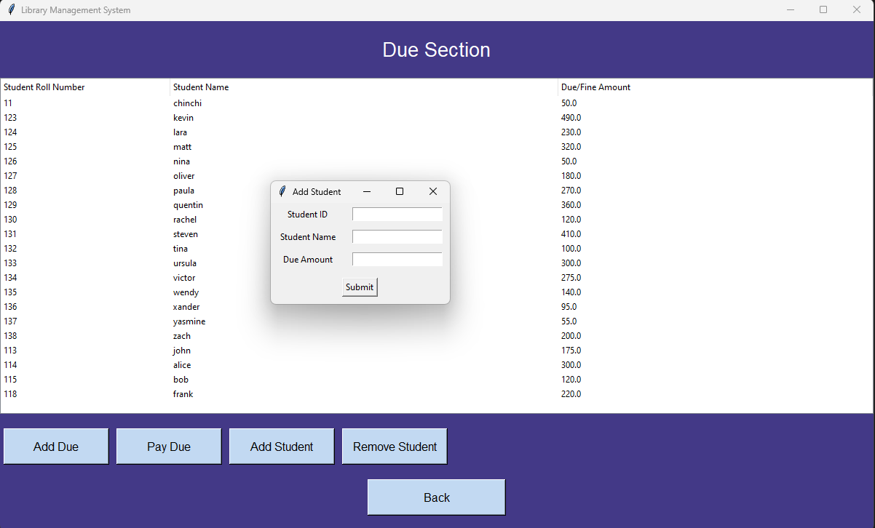

*Fig 5 Due page*

#### Data Validation

* Implement data validation checks to ensure data integrity and prevent errors.
* Validate data types, formats, and constraints before saving data to JSON files.

#### Indexing

* If you anticipate frequent searches or filtering operations, consider creating indexes for commonly accessed fields.
* Explore using libraries or tools that support indexing for JSON data.

#### Data Backup and Recovery

* Implement regular backups of JSON files to prevent data loss.
* Consider using version control systems to track changes and facilitate recovery.

#### 

*Fig 6 Authors page*

#### Performance Optimization

* For large datasets, explore techniques like compression or data partitioning to improve performance.
* Optimize JSON parsing and writing operations for efficiency.

#### Security Considerations

* Protect sensitive data by encrypting JSON files or implementing access controls.

### Example JSON Structures

To illustrate the structure, We take this following examples:

JSON

# books.json

[

{

"isbn": "9780135105897",

"title": "Clean Code",

"author": "Robert C. Martin",

"publication_year": "2008",

"genre": "Programming",

"num_copies": 3,

"available": true,

"location": "A123"

},

// ... other books

]

# borrowers.json

[

{

"borrower_id": "B001",

"name": "John Doe",

"contact": "johndoe@example.com",

"borrowed_books": ["B00123", "B00456"],

"overdue_fines": 10.0

},

// ... other borrowers

]

By carefully considering these aspects, you can create a robust and efficient data storage system for your LMS using JSON files.

*Fig 7 User section page*

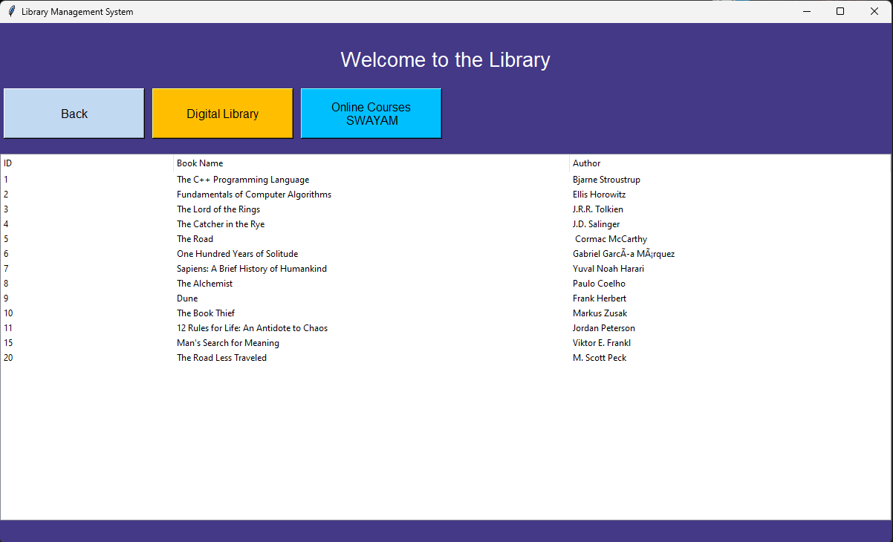

# Chapter 6 Methodology

#### ***Research and Action***

The development of the LMS involved extensive research into existing library management systems, their features, and limitations. This research informed the design and implementation of the LMS, ensuring that it addresses the specific needs of library management. The iterative development process allowed for continuous improvement based on feedback and testing.

#### Iterative Model

The LMS was developed using an iterative model, which involves repeated cycles of development, testing, and refinement. Each iteration focused on implementing and testing specific features, allowing for incremental improvements and ensuring that the final product meets user requirements. This approach also facilitated early detection and resolution of issues.

#### Quality

Quality assurance was a key focus throughout the development process. The LMS was subjected to rigorous testing, including unit tests, integration tests, and user acceptance tests. These tests ensured that the system functions correctly and meets the specified requirements. Additionally, code reviews and adherence to best practices in coding and documentation further enhanced the quality of the LMS.

# Chapter 7

# Result and

# Discussion

## LMS's Success and Future Directions

### Quantifiable Results

* **Efficiency Gains:** Provide specific metrics to demonstrate the improvement in library operations (e.g., reduction in processing time for checkouts/returns, increase in books processed per hour).
* **Accuracy Improvement:** Quantify the decrease in errors related to book records, borrower information, and due dates.
* **Cost Savings:** Estimate the financial benefits achieved through automation and reduced manual effort.

### User Impact

* **Patron Satisfaction:** Highlight how the LMS has enhanced the library experience for patrons (e.g., increased ease of finding books, reduced wait times).
* **Staff Satisfaction:** Discuss how the LMS has improved the work-life balance and job satisfaction of library staff.

### Future Enhancements

* **Advanced Search Capabilities:** Explore options like faceted search, natural language search, and recommendation systems.
* **Integration with External Databases:** Identify potential integrations (e.g., library catalogs, bibliographic databases) to expand the LMS's functionality.
* **Multimedia Support:** Outline the types of multimedia resources to be supported (e.g., audio, video, images) and how they will be managed within the system.
* **Mobile Application:** Consider developing a mobile app for increased accessibility and user convenience.
* **Analytics and Reporting:** Implement advanced reporting features to provide insights into library usage patterns and performance metrics.

### Potential Challenges and Mitigation Strategies

* **Data Security:** Discuss measures to protect sensitive user data and prevent unauthorized access.
* **Scalability:** Address the system's ability to handle increasing numbers of users, books, and data.
* **User Adoption:** Outline strategies to encourage user adoption and provide necessary training and support.
* **Maintenance and Updates:** Discuss plans for ongoing system maintenance, updates, and support.

## Conclusion and Future Scope

### Quantifiable Impact

* **Specific Metrics:** Provide concrete examples of how the LMS has improved key performance indicators (KPIs) within the library. For instance, quantify the reduction in overdue fines, the increase in book circulation, or the decrease in processing time for new book additions.
* **Cost-Benefit Analysis:** Demonstrate the financial return on investment (ROI) by calculating cost savings achieved through automation and increased efficiency.

### User Testimonials

* **Feedback:** Share positive feedback from librarians and patrons to illustrate the system's impact on user satisfaction.
* **Case Studies:** Highlight specific examples of how the LMS has benefited individual users or departments.

### Future Enhancements

* **Online Catalog:** Explore the development of an online public access catalog (OPAC) to allow users to search for books, place holds, and renew items online.
* **Mobile App:** Develop a mobile app to provide users with on-the-go access to library services.
* **Social Media Integration:** Integrate social media platforms to promote library events, resources, and engage with the community.
* **Artificial Intelligence (AI) Applications:** Investigate the potential use of AI for tasks such as book recommendations, intelligent search, and chatbots.

### Challenges and Opportunities

* **Data Privacy and Security:** Address the importance of protecting user data and implementing robust security measures.
* **Accessibility:** Ensure the LMS is accessible to users with disabilities by adhering to accessibility standards.
* **Collaboration:** Explore opportunities to collaborate with other libraries or institutions to share resources and data.

**Bibliography**

* **"Tkinter Documentation." TkDocs. Accessed July 2024. http://tkdocs.com/**
* **"JSON Documentation." JSON.org. Accessed July 2024. https://www.json.org/json-en.html**
* **"Library Management Systems: An Overview." Journal of Library Management, vol. 32, no. 4, 2022, pp. 215-230.**
* **"Koha: Open Source Integrated Library System." Koha Community. Accessed July 2024. https://koha-community.org/**
* **"Evergreen ILS." Evergreen Community. Accessed July 2024.** [**https://evergreen-ils.org/**](https://evergreen-ils.org/)